Project Documentation

SPENDWISE

1.INTRODUCTION

PROJECT TITLE: SPENDWISE– A Simple Backend Learning Project using Node.JS, Express, Mongo DB, and JWT

TEAM ID: NM2025TMID38573

TEAM LEADER: RENUKAPRIYA.S [Coder]

MAIL ID: priyarenuka060@gmail.com

TEAM MEMBERS:

NAME: RAKSHIYA.S [DOCUMENTOR]

MAIL ID: s.rakshya08@gmail.com

NAME: RAMYA.R [VOICE OVER]

MAIL ID: ramya.r37161@gamil.com

NAME: RINITHASRI.C.H [DOCUMENTOR]

MAIL ID: rinthasri577@gmail.com

NAME: ROSHINI.S (VIDEO EDITOR)

MAIL ID: roshiniroshini1194@gmail.com

2. PROJECT OVERVIEW
Spendwise is a backend application designed to help beginner developers learn how to build secure REST APIs using Node.js, Express, Mongo DB, and JWT authentication. The project focuses on implementing user authentication and basic CRUD operations in a clean and simple way so students can understand how backend systems work in real-world scenarios

- FEATURES:

User Registration & Login
- Secure sign-up and login system
- Password protection and profile management

Income & Expense Tracking
- Add, edit, and delete transactions
- Record date, amount, category, and description
- Separate income and expense
Categorization
- Predefined categories (Food, Transport, Bills, Shopping, etc.)
- Option to create custom categories
Target Users:
- Beginner backend developers
- Students learning Node.js and Express
- Freshers preparing for technical interviews
- Anyone who wants a simple project to understand JWT and Mongo DB
- Learners who want hands-on practice with REST API

3. ARCHITECTURE PROJECT STRUCTURE

Application Layer (Backend)
Purpose:
Processes user requests and applies business rules.
Components:
- Authentication module (Login/Signup)
- Expense management logic
- Budget calculation logic
- Report generation module
- API services
Technologies (Example):
- Node.js / Express
- Python (Django /Flask)
- Java (Spring Boot)
- PHP
Function:
- Validates user input
- Performs calculations
- Communicates with database
- Returns results to frontend

Data Layer (Database)
Purpose:
Stores and manages all application data.
Data Stored:
- User details
- Income records
- Expense records
- Budget settings
- Savings goals
Technologies (Example):
- MySQL
- Postgre SQL
- Mongo DB
- Firebase

SETUP INSTRUCTION

PREREQUISITES:

Software Requirements

Software | Purpose
Node.js | JavaScript runtime for backend
Mongo DB | No SQL database for data storage
npm | Package manager
Git | Version control system

- Knowledge Requirements

- JavaScript ES6+
- Node.js and Express.js
- Mongo DB and Mongoose
- JWT authentication
- Basic REST API concepts
- Git basics

Thumbnail for Project
- A simple backend project thumbnail representing:
Node.js + Express + Mongo DB + JWT + CRUD APIs

  - PROJECT STRUCTURE
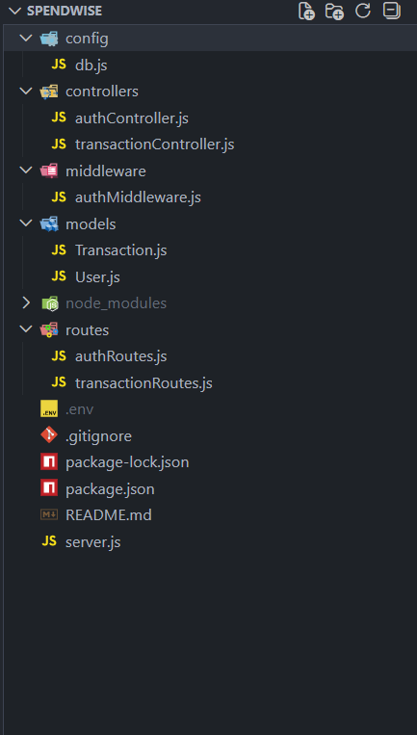

6. RUNNING THE APPLICATION
- FRONTEND
The frontend is like the face of Spend Wise—what you see and click when you visit the app.

- BACKEND
The backend is like the brain and engine of Spend Wise—it manages data, processes logic, and responds to what the frontend (user interface) requests.

- ACCESS
Visit http://localhost:5000
7. PROJECT EXECUTION
- Project Execution Steps
1. Start Mongo db
2. Run backend server
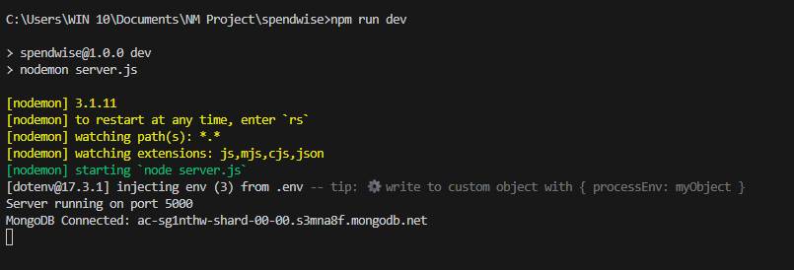
3.Test Register API
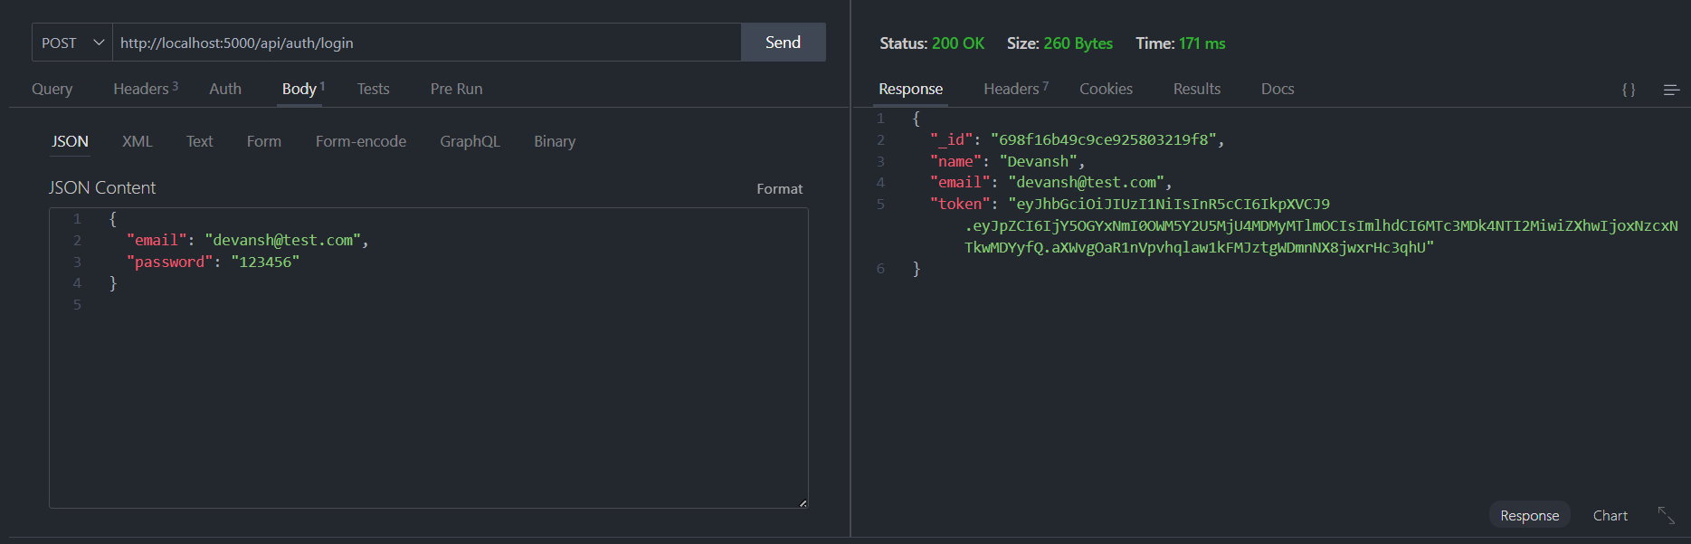

4. Copy JWT token
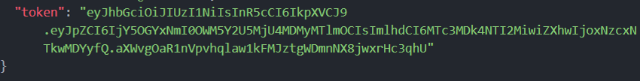

5. Use token to access protected CRUD APIs
6. Perform Create, Read, Update, Delete operations

OUTPUT

- Register API
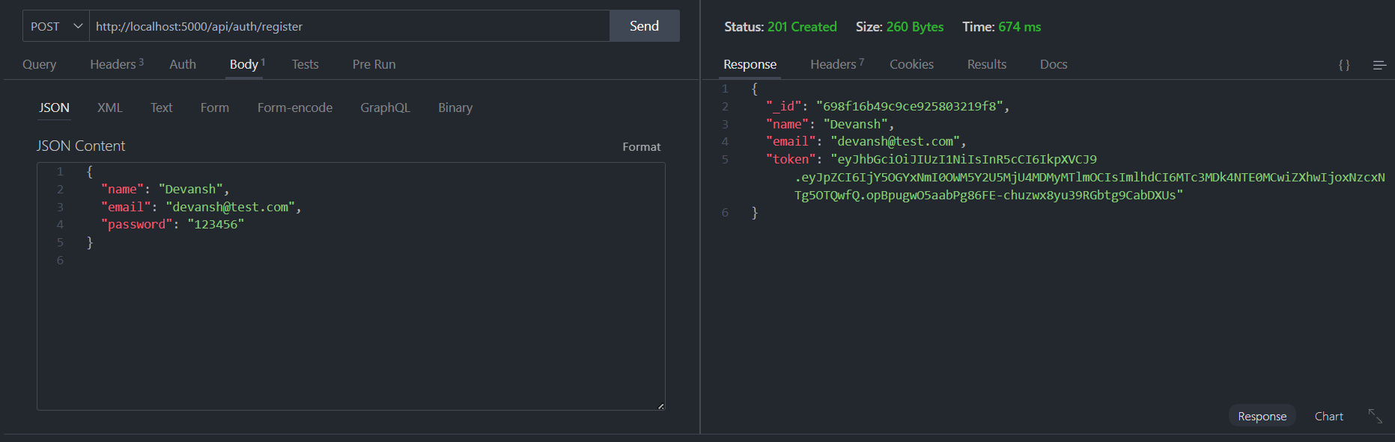

- Login API



- Create Transaction
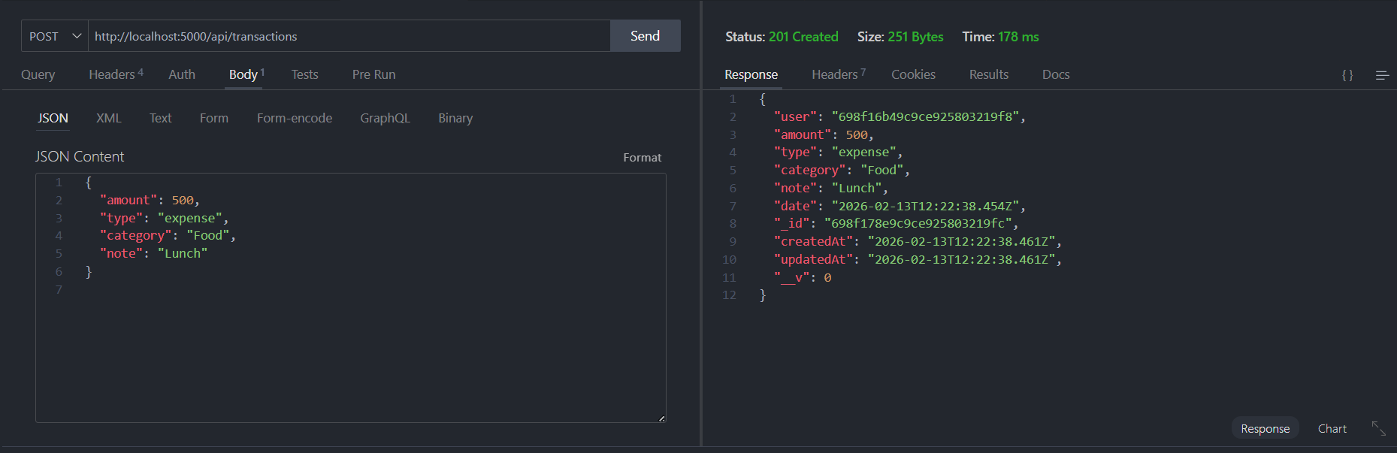

- Get information
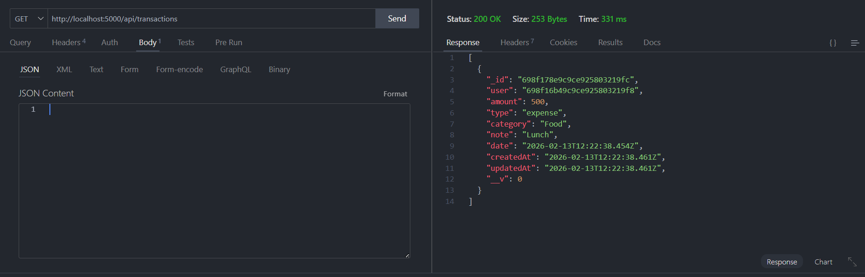

- Update API
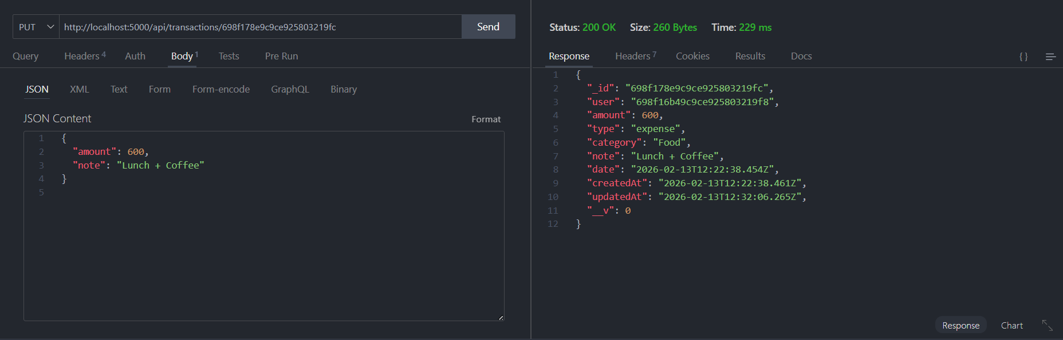

- Delete API
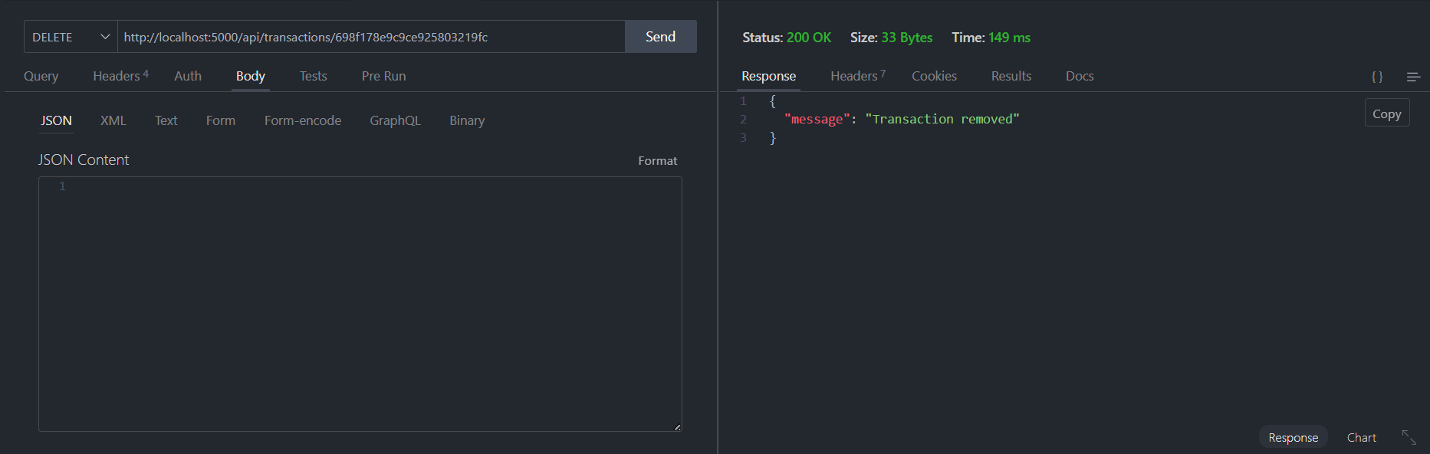

DEMO VIDEO LINK:
https://drive.google.com/file/d/1M171qKyhX5JwnmaLZ3bjDjpfJyQsirXL/view?usp=drivesdk
9. FUTURE ENHANCEMENT

- AI–BASED SMART EXPENSE PREDICTION
This concept uses artificial intelligence to analyse a user’s past spending patterns and predict future expenses. The system identifies trends in categories like food, travel, and utilities, and provides early warnings if the user is likely to exceed their monthly budget. It helps users plan proactively rather than reactively.

- PERSONALIZED FINANCIAL HEALTH SCORE
This feature calculates a dynamic financial score based on savings rate, expense stability, debt ratio, and budgeting discipline. The score updates in real time and provides suggestions to improve financial health, making money management measurable and goal-oriented.

- REAL-TIME SPENDING ALERT SYSTEM
Spend Wise could include a smart notification engine that sends alerts when spending crosses predefined thresholds. Using AI, the system can detect unusual or abnormal transactions and immediately notify the user to prevent financial risks.

